# Instructions: Recording in-person teaching with Panopto

Recording in browser.

## **Step 1:**

## Open the presentation you intend to share for the lecture.

## **Step 2:**

Open Panopto in the browser. Look for the **create** button.

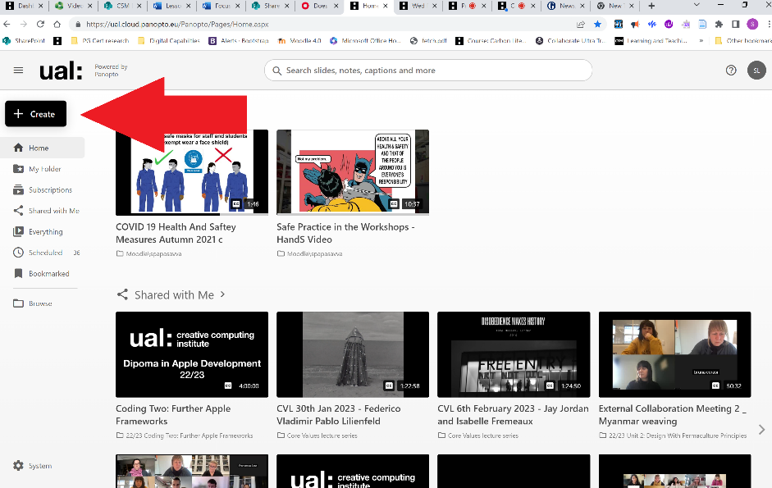

## **Step 3:**

Find the **Panopto Capture** link in the drop-down menu and select it.

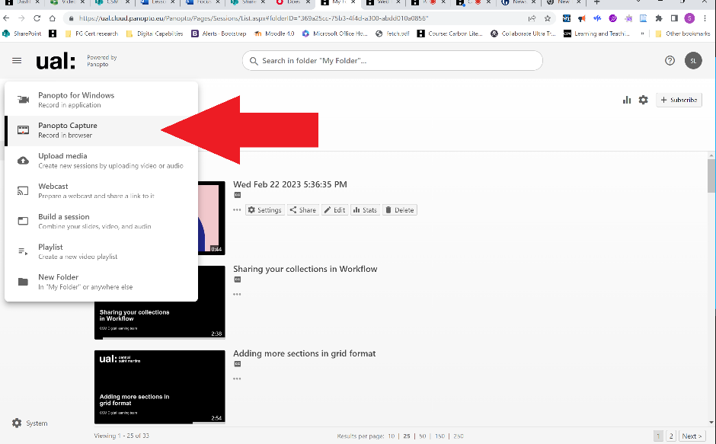

## **Step 4:**

The Panopto recorder tool will open in your next browser tab.

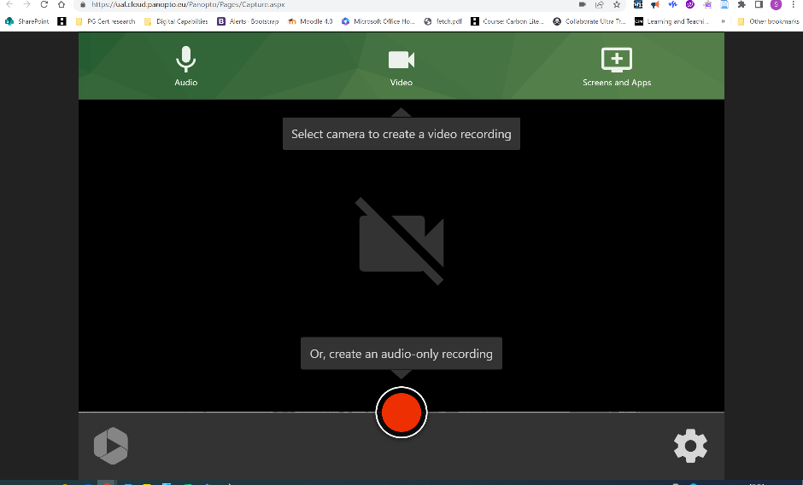

## **Step 5:**

Check the **correct microphone** is selected. You will need to make sure the mic can pick up your voice when you are giving a lecture. If you are going to move about you can get a clip mic. LTS can assist you with mics.

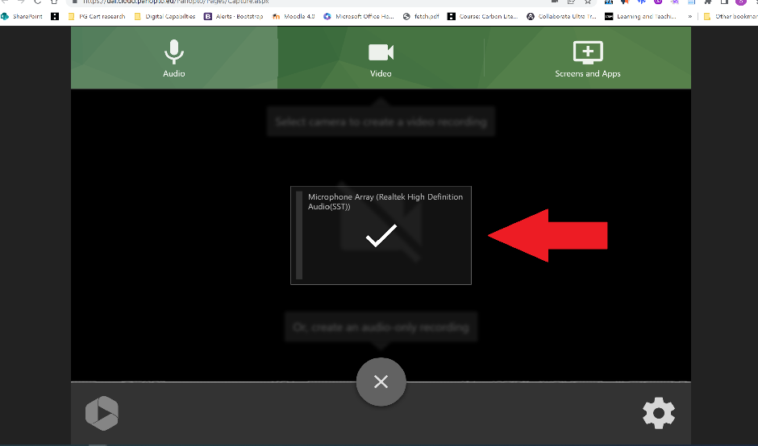

## **Step 6:**

Check the **video settings**. I have turned my camera off, so I only record the lecture. You can add your camera if you have one set up.

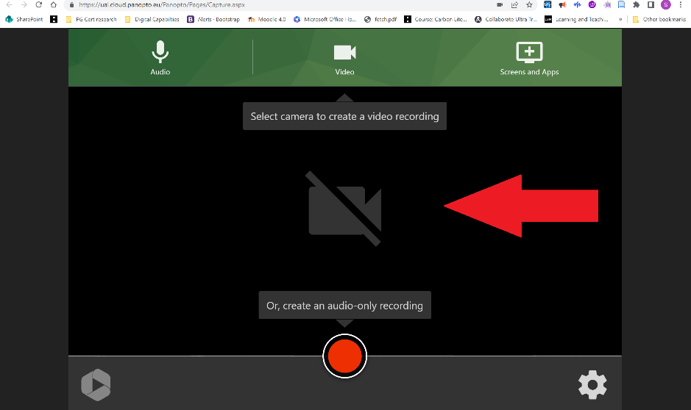

## **Step 7:**

Click the **screens and app button**. Then choose to share a Chrome tab, or Window or entire screen.

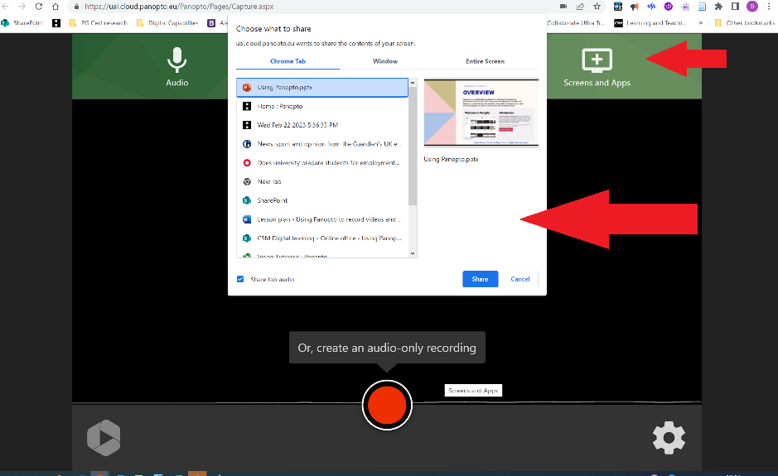

## **Step 8:**

When you are ready to start presenting, press the **record button**.

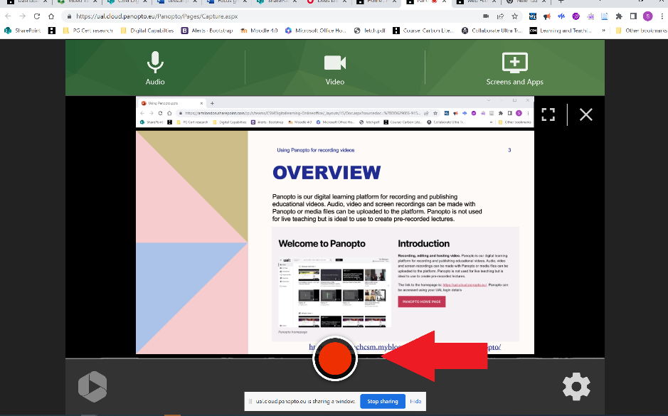

Nb/ you should leave this running while you give your lecture.

## **Step 9:**

After giving your lecture, you can **stop recording**.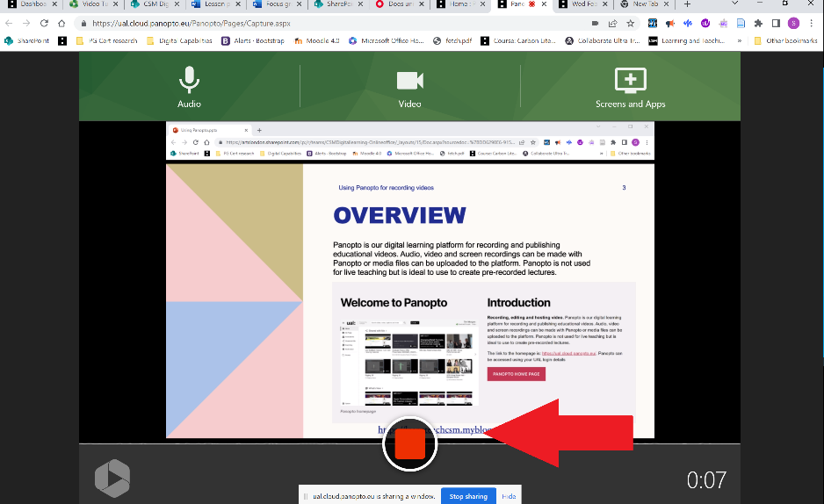

## **Step 10:**

After you press stop recording, you will see this screen. There are several quick options. For example, it will show you how long it has left to process the recording, and you can change the folder where the video gets saved. Just remember to check where it is going to be saved, so you can find it. If you want the recording to go straight to your **course Moodle page**, you can do this here. You can also make all these changes in the main Panopto application anyway.

